Screenshots or program listings must be copied into appropriate cells in the following table.
Save this evidence document as evidence_ followed by your centre number_ candidate number, for example, evidence_ zz999_9999 and insert your name, centre number and candidate number into the header above.
Examiners must be able to read the contents including any screenshots without the use of a magnifying glass. Answers that are not readable or are missing will not be awarded any marks.
Save this evidence document at regular intervals, for example every 10 minutes.
Question 1
Part 1(a)
{Copy and paste program code listing for Question 1(a) here}
#main
Animals=["" for _ in range(10)]

Part 1(b)
{Copy and paste program code listing for Question 1(b) here}
#main
Animals=["" for _ in range(10)]
Animals[0]="horse"
Animals[1]="lion"
Animals[2]="rabbit"
Animals[3]="mouse"
Animals[4]="bird"
Animals[5]="deer"
Animals[6]="whale"
Animals[7]="elephant"
Animals[8]="kangaroo"
Animals[9]="tiger"

Part 1(c)
{Copy and paste program code listing for Question 1(c) here}
def SortDescending():
global Animals
ArrayLength=len(Animals)
for x in range(ArrayLength):
for y in range(ArrayLength-x-1):
if Animals[y][0:1]<Animals[y+1][0:1]:
Temp=Animals[y]
Animals[y]=Animals[y+1]
Animals[y+1]=Temp

Part 1(d)(i)
{Copy and paste program code listing for Question 1(d)(i) here}

#main
Animals=["" for _ in range(10)]
Animals[0]="horse"
Animals[1]="lion"
Animals[2]="rabbit"
Animals[3]="mouse"
Animals[4]="bird"
Animals[5]="deer"
Animals[6]="whale"
Animals[7]="elephant"
Animals[8]="kangaroo"
Animals[9]="tiger"
SortDescending()
for animal in Animals:
print(animal)

Part 1(d)(ii)
{Copy and paste the screenshot for Question 1(d)(ii) here}

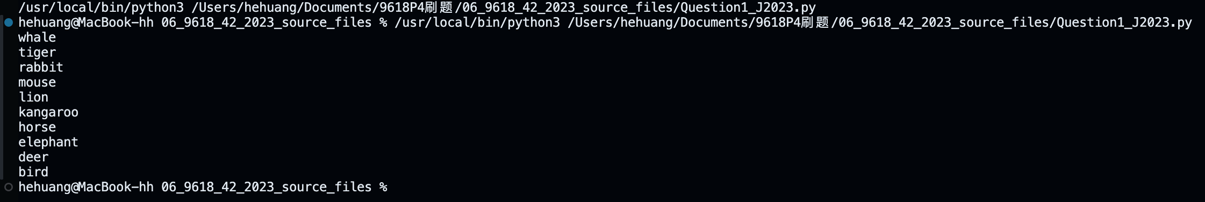

Question 2
Part 2(a)
{Copy and paste program code listing for Question 2(a) here}
class SaleData:
def __init__(self,id,quant):
self.ID=id
self.Quantity=quant

Part 2(b)
{Copy and paste program code listing for Question 2(b) here}
#main
CircularQueue=[SaleData("",-1) for _ in range(5)]
Head=0
Tail=0
NumberOfItems=0

Part 2(c)
{Copy and paste program code listing for Question 2(c) here}
def Enqueue(New):
global Head,Tail,NumberOfItems
global CircularQueue
if NumberOfItems >= len(CircularQueue):
return -1
CircularQueue[Tail]=New
Tail+=1
if Tail >=len(CircularQueue):
Tail=0
NumberOfItems+=1
return 1

Part 2(d)
{Copy and paste program code listing for Question 2(d) here}
def Dequeue():
global Head,Tail,NumberOfItems
global CircularQueue
if NumberOfItems==0:
return SaleData("",-1)
DataToReturn=CircularQueue[Head]
Head+=1
if Head >= len(CircularQueue):
Head=0
NumberOfItems-=1
return DataToReturn

Part 2(e)
{Copy and paste program code listing for Question 2(e) here}
def EnterRecord():
id=input("Enter the ID of the new sale record. ")
q=int(input("Enter the quantity of the new sale record. "))
NewSaleRecord=SaleData(id,q)
Status=Enqueue(NewSaleRecord)
if Status==1: print("Stored")
else: print("Full")

Part 2(f)(i)
{Copy and paste program code listing for Question 2(f)(i) here}

#main
CircularQueue=[SaleData("",-1) for _ in range(5)]
Head=0
Tail=0
NumberOfItems=0
for i in range(6):
EnterRecord()
sd=Dequeue()
if sd.ID=="": print("The circular queue is empty")
else: print(f"ID: {sd.ID}, Quantity: {sd.Quantity}")
EnterRecord()

for item in CircularQueue:
print(f"ID: {item.ID}, Quantity: {item.Quantity}")

Part 2(f)(ii)
{Copy and paste screenshot for Question 2(f)(ii) here}
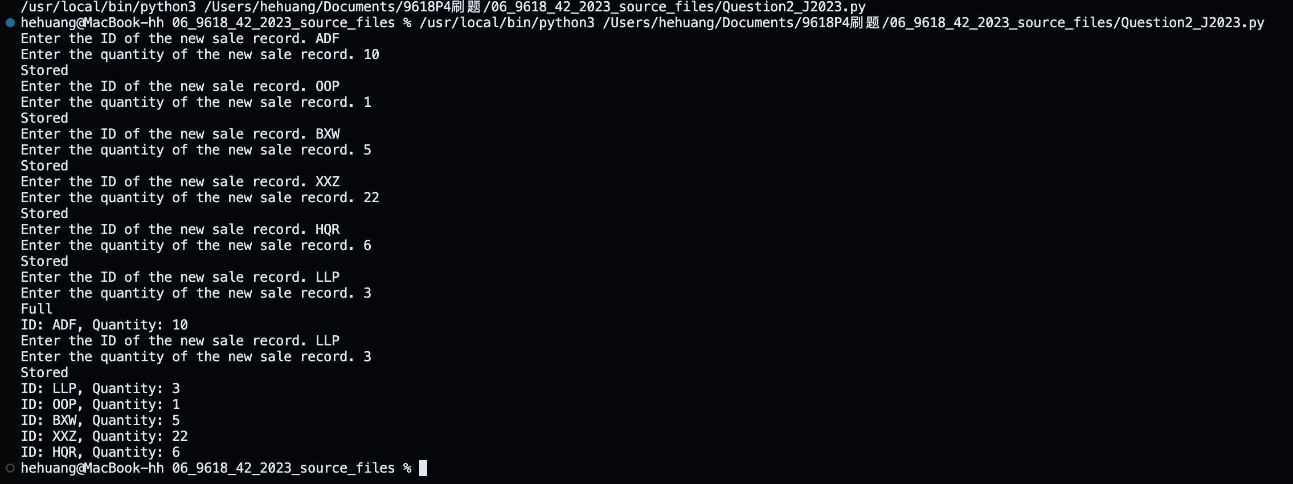

Question 3
Part 3(a)(i)
{Copy and paste program code listing for Question 3(a)(i) here}
class Employee:
def __init__(self,hp,en,jt):
self.__HourlyPay=hp #PRIVATE HourlyPay: REAL
self.__EmployeeNumber=en #PRIVATE EmployeeNumber: STRING
self.__JobTitle=jt #PRIVATE JobTitle: STRING
self.__PayYear2022=[0.0 for _ in range(52)] #PRIVATE PayYear2022: ARRAY[0:51] OF REAL

Part 3(a)(ii)
{Copy and paste program code listing for Question 3(a)(ii) here}
class Employee:
def __init__(self,hp,en,jt):
self.__HourlyPay=hp #PRIVATE HourlyPay: REAL
self.__EmployeeNumber=en #PRIVATE EmployeeNumber: STRING
self.__JobTitle=jt #PRIVATE JobTitle: STRING
self.__PayYear2022=[0.0 for _ in range(52)] #PRIVATE PayYear2022: ARRAY[0:51] OF REAL

def GetEmployeeNumber(self): return self.__EmployeeNumber

Part 3(a)(iii)
{Copy and paste program code listing for Question 3(a)(iii) here}
class Employee:
def __init__(self,hp,en,jt):
self.__HourlyPay=hp #PRIVATE HourlyPay: REAL
self.__EmployeeNumber=en #PRIVATE EmployeeNumber: STRING
self.__JobTitle=jt #PRIVATE JobTitle: STRING
self.__PayYear2022=[0.0 for _ in range(52)] #PRIVATE PayYear2022: ARRAY[0:51] OF REAL

def GetEmployeeNumber(self): return self.__EmployeeNumber

def SetPay(self,week,hrs):
self.__PayYear2022[week-1]=hrs*self.__HourlyPay

Part 3(a)(iv)
{Copy and paste program code listing for Question 3(a)(iv) here}
class Employee:
def __init__(self,hp,en,jt):
self.__HourlyPay=hp #PRIVATE HourlyPay: REAL
self.__EmployeeNumber=en #PRIVATE EmployeeNumber: STRING
self.__JobTitle=jt #PRIVATE JobTitle: STRING
self.__PayYear2022=[0.0 for _ in range(52)] #PRIVATE PayYear2022: ARRAY[0:51] OF REAL

def GetEmployeeNumber(self): return self.__EmployeeNumber

def SetPay(self,week,hrs):
self.__PayYear2022[week-1]=hrs*self.__HourlyPay

def GetTotalPay(self):
result=0
for num in self.__PayYear2022:
result+=num
return result

Part 3(b)(i)
{Copy and paste program code listing for Question 3(b)(i) here}
class Manager(Employee):
def __init__(self, hp, en, jt, bv):
super().__init__(hp, en, jt)
self.__BounusValue=bv #PRIVATE BounusValue: REAL

Part 3(b)(ii)
{Copy and paste program code listing for Question 3(b)(ii) here}
class Manager(Employee):
def __init__(self, hp, en, jt, bv):
super().__init__(hp, en, jt)
self.__BounusValue=bv #PRIVATE BounusValue: REAL

def SetPay(self, week, hrs):
hrs+=(self.__BounusValue/100)*hrs
super().SetPay(week, hrs)

Part 3(c)
#main
EmployeeArray=[Employee(-0.1,"","") for _ in range(8)]
fr=open("Employees.txt",'r')
x=fr.readline().strip()
count=0
while x != "":
HourPay=float(x)
EmNum=fr.readline().strip()
temp=fr.readline().strip()
if temp[0]>="A" and temp[0]<="Z":
jt=temp
EmployeeArray[count]=Employee(HourPay,EmNum,jt)
else:
bv=float(temp)
jt=fr.readline().strip()
EmployeeArray[count]=Manager(HourPay,EmNum,jt,bv)

count+=1
x=fr.readline().strip()

fr.close()

Part 3(d)
{Copy and paste program code listing for Question 3(d) here}
def EnterHours():
global EmployeeArray
fr1=open("HoursWeek1.txt",'r')
x=fr1.readline().strip()
while x != "":
id=x
hrs=float(fr1.readline().strip())
for staff in EmployeeArray:
if staff.GetEmployeeNumber() == id:
staff.SetPay(1,hrs)

x=fr1.readline().strip()
fr1.close()

Part 3(e)(i)
#main
EmployeeArray=[Employee(-0.1,"","") for _ in range(8)]
fr=open("Employees.txt",'r')
x=fr.readline().strip()
count=0
while x != "":
HourPay=float(x)
EmNum=fr.readline().strip()
temp=fr.readline().strip()
if temp[0]>="A" and temp[0]<="Z":
jt=temp
EmployeeArray[count]=Employee(HourPay,EmNum,jt)
else:
bv=float(temp)
jt=fr.readline().strip()
EmployeeArray[count]=Manager(HourPay,EmNum,jt,bv)

count+=1
x=fr.readline().strip()

fr.close()

Part 3(e)(ii)
{Copy and paste screenshot for Question 3(e)(ii) here}
